**Composition:**

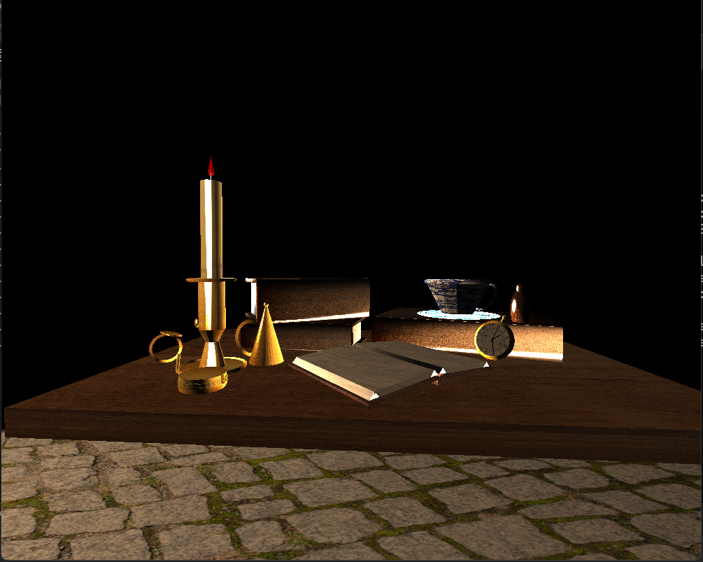

1. **Justify development choices for your 3D scene. Think about why you chose your selected objects. Also consider how you were able to program for the required functionality.**

My 3D scene consists of a high-contrast composition of objects arranged on a wooden table. The different objects (some repeated) include: a bronze cylindrical box, a bronze candlelight, a bronze candle cover, a closed book, an open book, a pocket watch with a bronze lining, a wooden bottle-shaped object, and a teacup.

My main development choices were the selection of primitives to construct each object, the placement of high-contrast lighting, and the selection of textures and materials. Another important decision was the implementation of object render functions, which allow me to render identical objects multiple times and transform them individually.

To deepen my understanding of computer graphics, I relied on the course resources, especially LearnOpenGL. This helped me understand how primitives are rendered through the graphics pipeline and how colors and textures are interpolated in the fragment shader. With this knowledge, I implemented the project by loading the chosen primitives and textures. I selected the 2D reference image because I found it visually appealing, with a strong arrangement of objects and excellent perspective. Additionally, the lighting configuration in the image provides depth and contrast, making it ideal for showcasing the 3D effect on all objects.

1. **Explain how a user can navigate your 3D scene. Explain how you set up to control the virtual camera for your 3D scene using different input devices.**

The user has two ways to navigate the 3D scene.

Using the keyboard, the user can press W, A, S, and D to move forward, backward, and sideways, while Q and E are used to move up and down. The O and P keys switch the camera between orthographic and perspective views, respectively. The number keys 1 through 4 provide various orthographic side and top views of the composition.

Using the mouse, the user can make limited movements to explore the scene from the camera’s current position. Additionally, the mouse wheel adjusts the camera’s movement speed.

1. **Explain the custom functions in your program that you are using to make your code more modular and organized. Ask yourself, what does the function you developed do and how is it reusable?**

My main custom functions are the renderObject() functions. They are responsible for initially setting the position of each primitive that makes up a single object. For example, the candlelight render function arranges the toruses and cylinders to form a candlelight object at the origin.

The function then applies the global coordinates of the object within the overall composition, allowing for scaling, rotation, and translation as desired by the user. This not only helps me organize my code but also makes it easy to programmatically position each object with a single parameter that controls all its primitives.

Additionally, this approach allows me to render multiple similar objects with variations, such as different sizes for multiple books in the scene. Finally, each function also assigns textures to the corresponding primitives.